1. **Js.html**

<html>

<body>

<script language = "javascript" type = "text/javascript">

document.write("Hello World!");

var a = 33;

var b = 10;

var c = "Test";

document.write("<br><br> a + b = ");

result = a + b;

document.write(result);

document.write(c);

var age = 15;

if( age > 18 ) {

document.write("<br><br><b>Qualifies for driving</b><br>");

} else {

document.write("<br><br><b>Does not qualify for driving</b><br>");

}

var count;

document.write("<br>Starting Loop" + "<br />");

for(count = 0; count < 10; count++) {

document.write("Current Count : " + count );

document.write("<br />");

}

document.write("Loop stopped!");

</script>

</body>

</html>

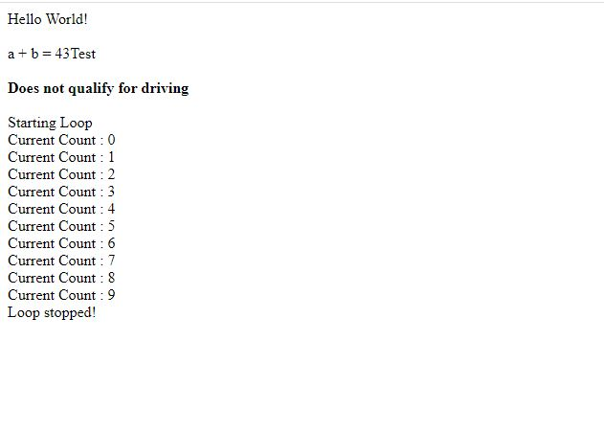

1. Js1.html

<html>

<body>

<script language = "javascript" type = "text/javascript">

var house = new Array(10, 20, 30, 40, 50);

//Creates an array of 5 undefined elements

var house1 = new Array(5);

//Creates an array with element

var home = new Array("1BHK");

var len = house.length;

for (var i = 0; i < len; i++)

document.write(house[i]);

</script>

</body>

</html>

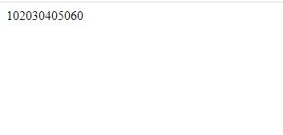

1. Js2.html

<html>

<body>

<h2>Finding HTML Elements by Id</h2>

<p id="intro">Hello World!</p>

<p>This example demonstrates the <b>getElementsById</b> method.</p>

<p id="demo"></p>

<script>

var myElement = document.getElementById("intro");

document.getElementById("demo").innerHTML =

"The text from the intro paragraph is " + myElement.innerHTML;

</script>

</body>

</html>



